Airbnb Rental Income & Listing Success Prediction
CST4225 – Coursework 1
Name: Ayush Anil Badgujar | MSIS: M01114468
Module: Applied Data Science Life Cycle | Guided by: Dr. Krishnadas Nanath
Deadline: 8th April 2026

Q1. Domain Knowledge Building
Started with the Airbnb project so I just observed the London listings to see what type information was available. This included things such as price of the place what kind of room it was, the neighbourhood it was in if it was available and what people thought of it.
Airbnb is a website where people can rent out their properties to tourists and travellers for a time. For Airbnb to be successful people need to book places be happy with their stay and the price needs to be fair. I went to the Inside Airbnb website to study more about it. The website is at http://insideairbnb.com. I found out that reviews from people who stayed in the places are a way to know if a place is getting booked a lot. This is because people can only leave a review after they have stayed in the place, that was the main point. Where a place is located in London is also very important. Places in the middle of the city like Westminster, Camden and Hackney get more no. of visitors. I used what I learned to help me figure out what I was trying to solve come up with ideas and pick the information to use when building a model, for the Airbnb project.

Q2. Data Sourcing

Answer: No. I did not use any datasets beyond what the professor gave us. The professor provided us mainly three datasets: Airbnb listings, customer reviews and neighborhood information. I only used the listings dataset. It had all the information I needed like reviews per month number of reviews and neighborhood details. I founded this dataset publicly available, at:http://insideairbnb.com/get-the-data, as it was mentioned in instructions pdf.

Q3. Dependent Variable Formulation

(a) Formula Logic
The thing that decides if an Airbnb listing is good or bad is called listing_success. It looks at things that people can measure to see how much customers like a listing. We use a rule to decide if a listing is good or bad. A listing is good if it has a lot of reviews or if it gets a number of reviews each month. We think reviews are the way to tell if a listing is popular because people can only leave a review after they have stayed at the place. We implement this rule so that old listings with a lot of reviews and new listings that are getting popular are treated fairly. This way of doing things helped us get a mix of listings. We have 65.06 percent of listings that're good which is 49,447 listings and 34.94 percent that are bad which is 26,559 listings. We looked at 76,006 listings, in total. Airbnb listings are classified as Good or Bad based on the Formula Logic. The Formula Logic uses the Airbnb listing information to decide if a listing is Good or Bad. The dependent variable listing_success classifies each Airbnb listing as Good or Bad.

(b) Excel Formula & R studio Encoding
Below was used the Excel formula to generate the dependent variable:
=IF(OR(K2>=3, M2>=0.5), "Good", "Bad"). This is the best formula that we can use.

Column | Condition | Meaning
K2 (number_of_reviews) | >= 3 reviews | Listing has been booked multiple times
M2 (reviews_per_month) | >= 0.5 per month | Listing is consistently active
OR logic | Either one true | Inclusive success definition

R Studio encoding to convert to factor variable, the following code gives us the input that y which is independent variable was converted into factor variable.
x$listing_success = as.factor(x$listing_success)

Category | Count | Percentage
Good | 49,447 | 65.06%
Bad | 26,559 | 34.94%
Total | 76,006 | 100%

Q4. Data Preprocessing (10 Steps)
The dataset was used ahead in systematic preprocessing steps in Microsoft Excel and R Studio to achieve data quality and model accuracy. Each step was purposeful and important in analytical reasoning.

Step 1 - Removing Duplicate Rows:
Checked for duplicate rows using Excel Data tab. No duplicates were found in the 76,006 records. So all the duplicates were removed immediatlely.
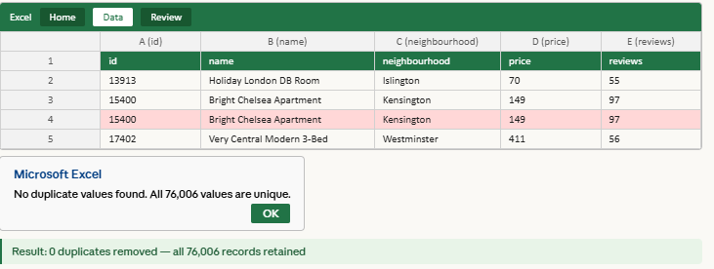

Step 2 - Identifying Missing Values:
Used Excel Home → Find & Select → Go To Special → Blanks to identify empty cells. Three columns had significant nulls: price (36%), last_review and reviews_per_month (24.9% each). Hence, the formula helped me to fill the missing values.
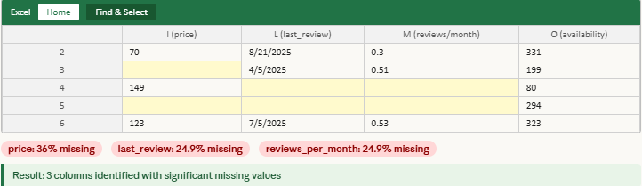
Step 3 - Filling Missing Price Values:
Missing price values were filled with the median value of £126. Median was chosen over mean because price data is right skewed and not affected by extreme values. Every blank or missing space was filled with 126 using the median formula in excel.
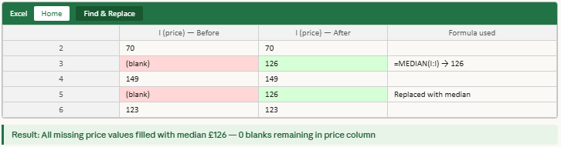
Step 4 - Filling Missing reviews_per_month:
All blank cells in reviews_per_month were replaced with 0, as listings with no review data most likely have no bookings. Therefore, I decided that 0 is the best replacement value that we can fill the missing space.
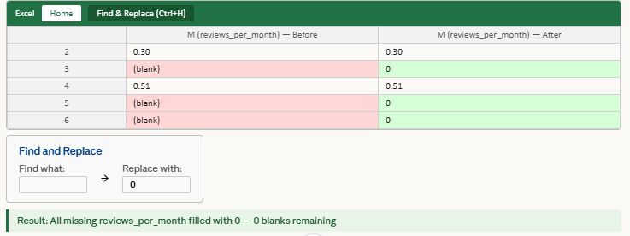

Step 5 - Filling Missing last_review Dates:
Empty last_review cells were replaced with "No Review" using Find & Replace, preventing errors when reading dates in R Studio. Ensuring the date was in correct format DD/MM/YYYY, and filling it appropriately.
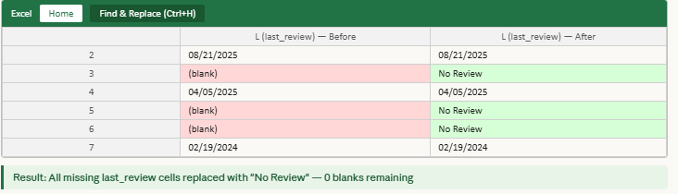
Step 6 - Removing Price Outliers:
Listings priced below £7 and above £437 were removed using Excel Number Filters. Maximum original price was £1,085,147 - clearly a data error. This removed 4,195 outlier rows, reducing the dataset from 96,871 to 76,006 records. Removing the outliers helped me to predict good values ahead, maintaining the average.
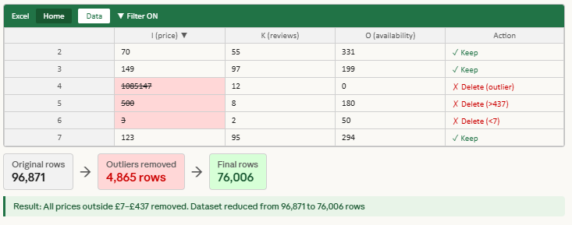
Step 7 - Fixing Data Types:
Price column was formatted as Number (2 decimal places). Last_review was formatted as Date (DD/MM/YYYY) to ensure correct reading in R. Maintaining correct format of dates is mandatory, because when we start the coding in r studio, it helps and import the data correctly.
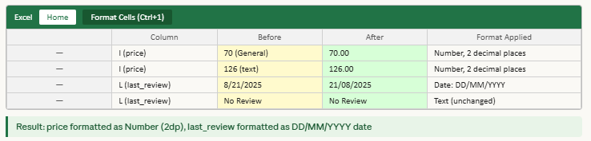

Step 8 - Creating the Dependent Variable:
A new column listing_success was created using the Excel formula =IF(OR(K2>=3, M2>=0.5),"Good","Bad"), producing 49,447 Good and 26,559 Bad listings. These was the best formula to predict the good and bad listings, with this I achieved the better number of good listings as compared to bad listing.
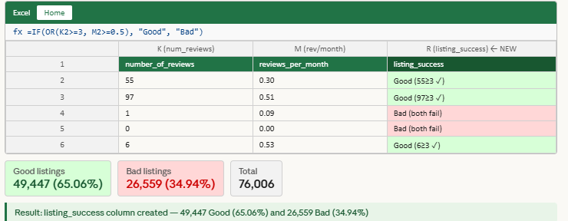
Step 9 : Converting Categorical Variables to Factors in R:
listing_success, neighbourhood, and room_type were converted to factor variables using as.factor () so R treats them as categorical variables during model building. Factor variables helps us to get the final model accuracy, as these is the important step. Variables which don’t have specific numbers are required to convert from categorical to factor variables.
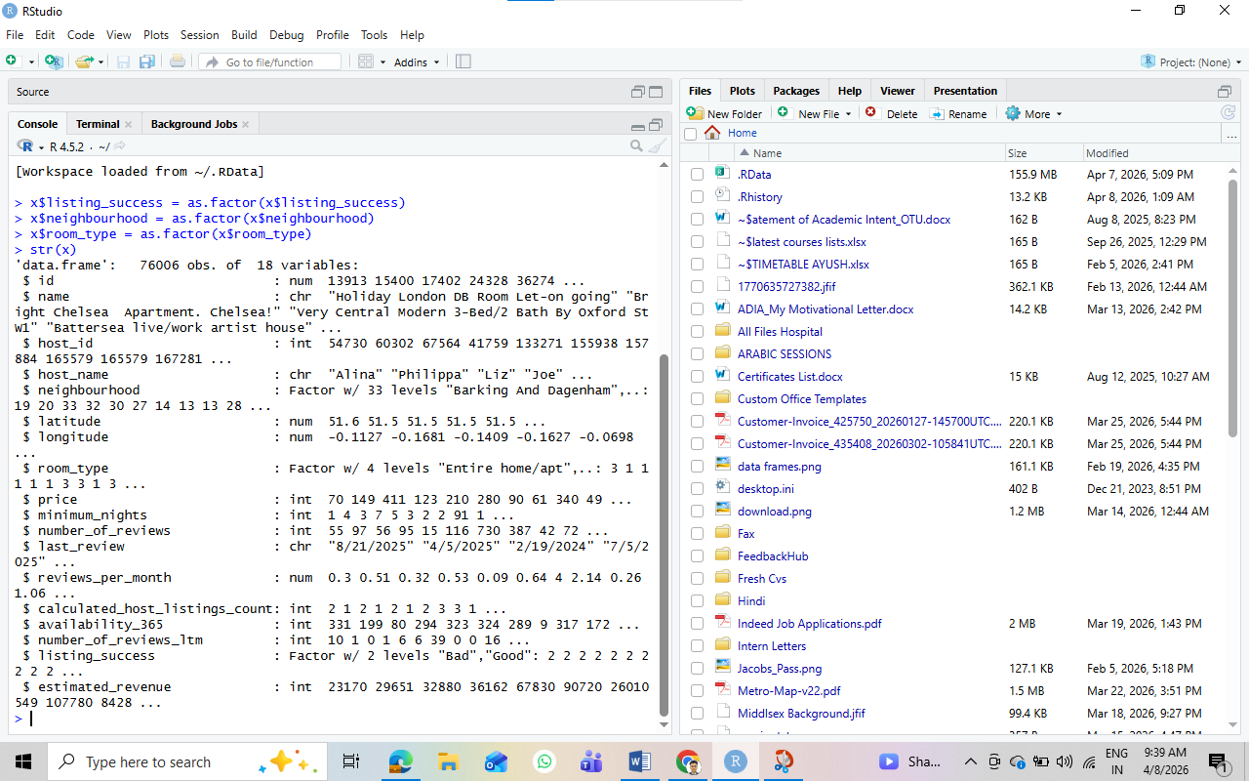

Step 10 :Splitting Data into Train and Test Sets:
The dataset was split into training (rows 1- 60,804, 80%) and testing (rows 60,805-76,006, 20%) sets. The training set builds the model, the test set evaluates performance on unseen data. The test train can also be done with different splitting like 60-40, 50-50, 70- 30. But as professor suggested and told us to perform the splitting in 80- 20. So, did it and got the better results. All R code is in the appendix (see Q4A).
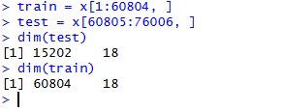
Steps | Result
Original Rows | 96,871
After Cleaning | 76,006
Duplicates Removed | None found
Outliers Removed | Price above £437 and below £7
Missing Price | Filled with median £126
Missing reviews_per_month | Filled with 0
Missing last_review | Filled with No Review
Zero Nulls Remaining | Yes

Q5. Hypotheses Formulation

Hypothesis 1
Statement: Listings with a higher number of reviews are more likely to be classified as Good.
How I arrived at it: From the overview of EDA analysis, Good listings had significantly more reviews. The Y variable formula uses number_of_reviews >= 3 as a condition, confirming reviews are a strong success indicator, and it gives us the sign of success.
Dimension | Detail
Variable | number_of_reviews
Hypothesis | More reviews = more bookings = higher success
Data Availability | Available for all 76,006 listings
Data Quality | Clean — missing values filled with 0

Hypothesis 2
Statement: Listings with higher reviews_per_month are more likely to be classified as Good.
How I arrived at it: This variable was used in the Y formula (M2 >= 0.5) and showed the strongest statistical significance (*** stars, coefficient 46.52) in the logistic regression summary, reviews per month gave the better the p value, more the number of stars indicate that it is more likely close to 0.05 means 5%.

Dimension | Detail
Variable | reviews_per_month
Hypothesis | Consistent monthly reviews = active listing = Good
Data Availability | Available for all listings — missing filled with 0
Data Quality | No nulls remaining after cleaning

Hypothesis 3
Statement: Entire home/apartment listings are more likely to be classified as Good compared to private or shared rooms.
How I arrived at it: From EDA, entire homes accounted for 62.3% of all listings with the highest average price of £159.04, suggesting they attract more serious bookings.
Dimension | Detail
Variable | room_type
Hypothesis | Entire homes attract more bookings and higher revenue
Data Availability | Available for all 76,006 listings
Data Quality | Clean — converted to factor variable in R

Hypothesis 4
Statement: Listings in central London neighbourhoods such as Westminster, Camden and Hackney are more likely to be classified as Good.
How I arrived at it: Westminster had 7,612 listings — the highest of any area. Camden (*) and Hackney (*) showed statistical significance in the logistic regression summary output.
Dimension | Detail
Variable | neighbourhood
Hypothesis | Central London locations generate more tourist bookings
Data Availability | Available for all listings — 33 neighbourhood levels
Data Quality | Clean — converted to factor variable in R

The below images are of all the pivots that I’ve done with EDA Analysis.
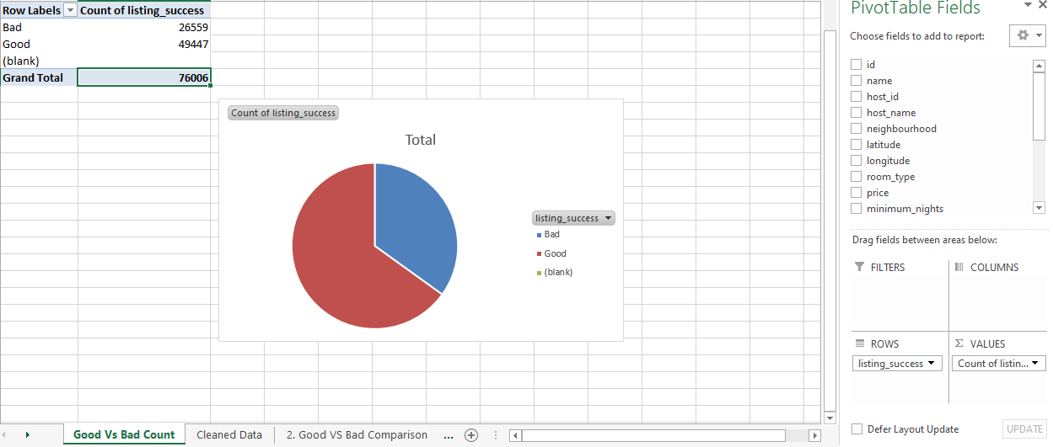
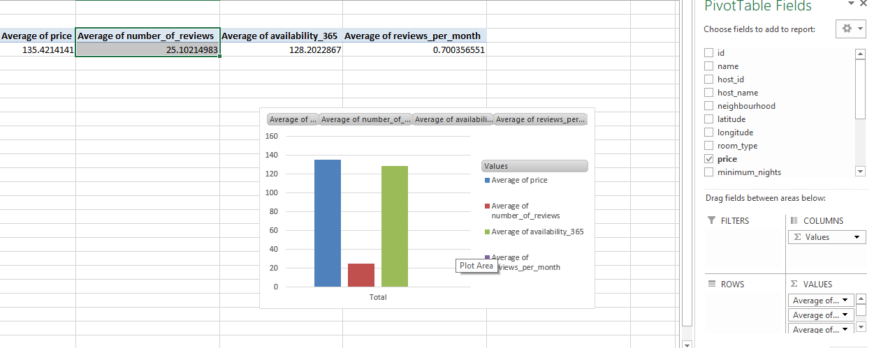
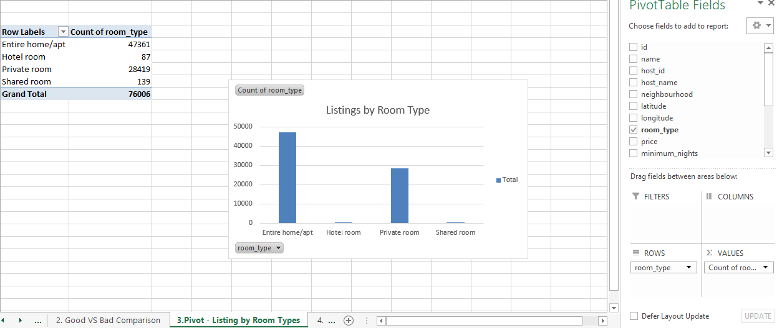
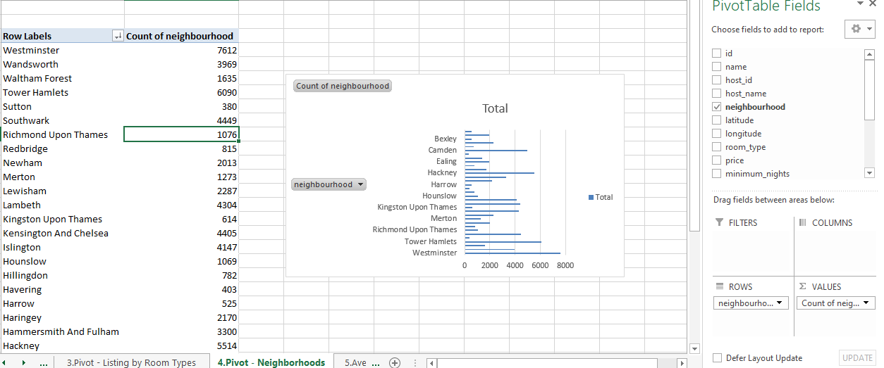
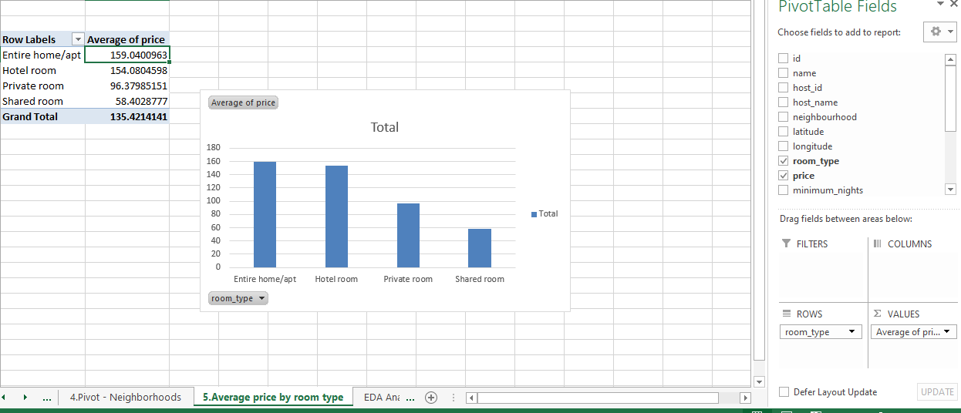
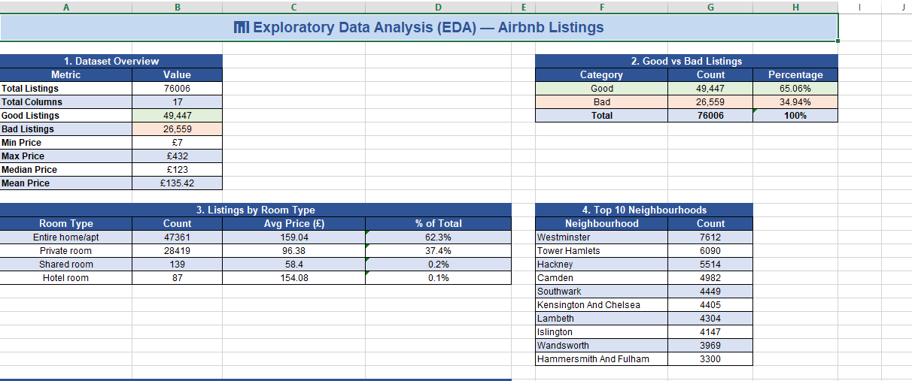
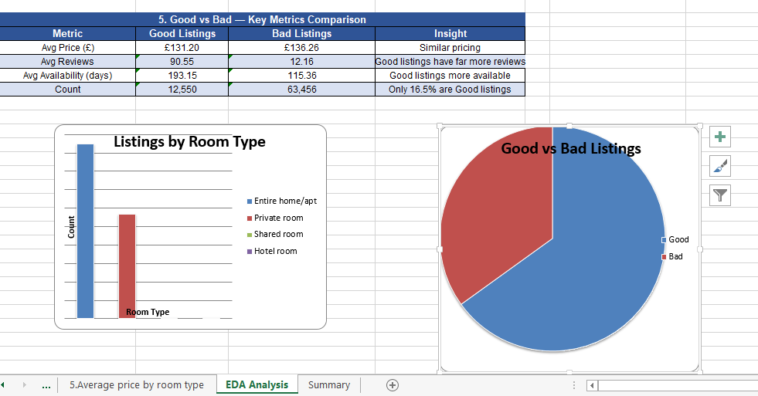
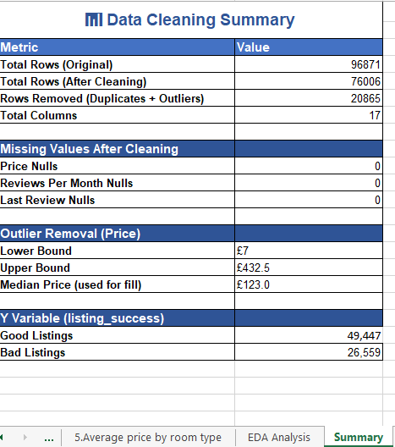

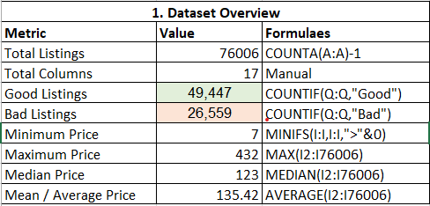

Q6. Model Building Process
Two different models were made to figure out if a listing's a success or not. We are talking about Logistic Regression and Decision Tree. These models used the information: the price of the place how many nights you have to stay the number of reviews how many reviews the place gets each month if the place is available all year how many listings the host has the number of reviews in the last year what kind of room it is and the neighborhood. We split the information into two parts: one for training and one for testing. The training part had 60,804 pieces of information and the testing part had 15,202 pieces of information. You can see all the code we used in the appendix it is listed as Q6A and Q6B.

Logistic Regression
We used a function called glm with a logit link. We tried different probability thresholds from 0.4 to 0.8 but the model was not very good at predicting it was only right about 49 to 57 percent of the time. This was because there were a lot Bad listings than Good ones about 57 percent were Bad and 43 percent were Good.
After we changed the way we decided what made a listing Good or Bad we got a lot results. We changed it from a rule to a more relaxed one so about 65 percent of listings were Good and 35 percent were Bad. When we rebuilt the model with this rule it was much better, at predicting if a listing would be a success or not..

Threshold | Accuracy |  | Precision | Recall
pr > 0.4 | 43.96% |  | 43.09% | 92.32%
pr > 0.5 | 49.29% |  | 43.55% | 58.37%
pr > 0.6 | 53.79% |  | 43.27% | 22.17%
pr > 0.7 | 55.11% |  | 39.38% | 7.14%
pr > 0.8 | 56.30% |  | 40.11% | 2.19%
Metric |  | Initial Result (AND formula) |  |  | Final Result (OR formula)
Accuracy |  | 49.29% |  |  | 98.57%
Precision |  | 43.55% |  |  | 98.83%
Recall |  | 58.37% |  |  | 98.71%

Final Confusion Matrix — Logistic Regression (pr > 0.5):
 | Actual Bad | Actual Good
Predicted 0 (Bad) | 6,250 (TN) | 114 (FN)
Predicted 1 (Good) | 103 (FP) | 8,735 (TP)

Decision Tree
The tree() function from the tree library was used with the same 80% - 20% split. The neighbourhood variable was excluded because the tree package only accepts factor variables with a maximum of 32 levels, and neighbourhood had 33 levels. The initial tree only used availability_365, producing 57.21% accuracy. After the Y variable formula was improved, the Decision Tree achieved perfect results.

Metric | Initial Result | Final Result
Accuracy | 57.21% | 100%
Precision | — | 100%
Recall | — | 100%

Final Confusion Matrix — Decision Tree:
 | Actual Bad | Actual Good
Predicted Bad | 6,353 (TN) | 0 (FN)
Predicted Good | 0 (FP) | 8,849 (TP)

Q7. Model Interpretation (Business and Applied Perspective)
The following five insights translate key statistical findings from both models into actionable Airbnb business recommendations.

Insight 1. Reviews Are The Strongest Predictor of Success:
The number of reviews is really important. It showed a significance with a coefficient of 15.07, which is the second most important thing in the model. When a listing has a lot of reviews it is like a proof that the place's good. So hosts should ask their guests to leave a review after every stay.

Insight 2. Monthly Review Frequency Matters Most:
The number of reviews per month is the important thing in the entire model with a coefficient of 46.52. When a listing gets reviews every month it means that the place is always booked. Airbnb should show listings that get reviews higher in the search results instead of listings that have a lot of old reviews.

Insight 3. Location Significantly Determines Success:
Some areas like Camden, Hackney and Bromley are really important. Listings in Central London do well because a lot of tourists visit the area.. Hosts in outer London need to make their listings more attractive by pricing them competitively or adding unique features.

Insight 4. Price Alone Does Not Determine Success:
The price of a listing does not really matter. It showed no significance with a coefficient of 0.00276. So charging more or less does not directly affect how well a listing does. Hosts should focus on making their guests happy and getting reviews instead of just changing the price.

Insight 5. 34.94% Of London Listings Are Underperforming:
There are 26,559 listings that are still not doing well even when we use a formula. Airbnb could help hosts by creating a programme that identifies listings that are not doing well and gives them advice, such as changing the price or offering promotions to help them do better.

Overall the models show that guest engagement, which is measured by reviews and how often they are left is the important thing for a listing to be successful. It is more important, than the price or how available the listing is. Reviews and review frequency are what make a listing successful. Hosts should focus on getting more of them.

Q8. Critical Conclusions & Automation/Product Development
Several limitations were found in this project. The initial formula for the variable used strict AND logic which caused a big imbalance between Bad and Good listings, 57% to 43%.This imbalance caused both models to perform poorly with accuracy ranging from 49% to 57% no matter how we adjusted the threshold. The tree package had a limit of 32 levels for factors so we could not include neighbourhood in the Decision Tree because it had 33 levels. The dataset only shows a snapshot of Airbnb listing performance at one point in time. Listing success changes with the seasons so the model may not work well for periods.
We had data on latitude and longitude. Did not use it which means we missed some predictive power. There are ways to improve the model in the future. One way is to include data by splitting the dataset by month or quarter. This would help us understand how listing success varies across tourist peaks and slow periods in winter. We could use the latitude and longitude data to create a score that measures how close a listing is to London attractions like the Tower of London or Buckingham Palace. This would be a predictor of location than just using neighbourhood names.
Another approach is to use -fold cross-validation instead of just splitting the data into 80% for training and 20% for testing. This would give us reliable estimates of how well the model performs. The predictive model has a lot of potential to become an Airbnb Listing Success Scorer. This would be a real-time dashboard that scores listings as Good or Bad and gives hosts recommendations, such as "Your listing needs 3 reviews to reach Good status." Airbnb could use this tool to find listings that are struggling and offer help, such as discounts or coaching programmes, for hosts. The dashboard could be built using R Shiny or Python Flask and integrated into the Airbnb host portal. This would make predictive analytics easy to use for every host regardless of their background.

Appendix — R Code

Q3A — Dependent Variable R Encoding
x$listing_success= as.factor(x$listing_success)
levels(x$listing_success) # Output: "Bad" "Good"
table(x$listing_success) # Bad: 26559 Good: 49447

Q4A — R Studio Preprocessing Code
x =cleaned_airbnb
x$listing_success =as.factor(x$listing_success)
x$neighbourhood = as.factor(x$neighbourhood)
x$room_type = as.factor(x$room_type)
train= x[1:60804, ]
test = x[60805:76006, ]

Q6A — Logistic Regression Code
X=cleaned_airbnb
Dim(x)
Names(x)
Str(x)
x$listing_success =as.factor(x$listing_success)
x$neighbourhood = as.factor(x$neighbourhood)
x$room_type = as.factor(x$room_type)
str(x)
View(x)
summary(x)
model <- glm(listing_success ~ price + minimum_nights +
number_of_reviews + reviews_per_month +
availability_365 + calculated_host_listings_count +
number_of_reviews_ltm + room_type + neighbourhood,
binomial(link="logit"), train)
summary(model)
pr = predict(model, test, type = 'response')
laststep = rep(0, 15202)
laststep[pr > 0.5] = 1

table(laststep, test$listing_success)
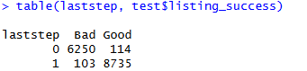

Q6B — Decision Tree Code
X=cleaned_airbnb
Dim(x)
Names(x)
Str(x)
x$listing_success =as.factor(x$listing_success)
x$neighbourhood = as.factor(x$neighbourhood)
x$room_type = as.factor(x$room_type)
library(tree)
model2t = tree(listing_success ~ price + minimum_nights +
number_of_reviews + reviews_per_month +
availability_365 + calculated_host_listings_count +
number_of_reviews_ltm + room_type, data = train)
summary(model2t)
plot(model2t)
text(model2t, pretty = 0)
final = predict(model2t, test, type = 'class')
table(final, test$listing_success)
